Configuration of the Blackberry Desktop Manager v4.0 software
- Plug your USB cable into the back of your computer, and then plug your Blackberry into the USB cable.
Windows should automatically detect and install the Blackberry driver for you. However, in some circumstances you may be greeted with the “Found New Hardware Wizard”. If the Windows “Found New Hardware Wizard” appears on your screen, choose Install the software automatically (Recommended) and click Next to continue.
If you do not see this screen, just proceed to the next step.
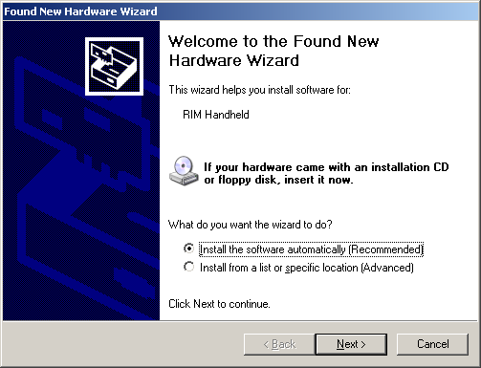

- The driver for the Blackberry will begin to install automatically. [Note to Windows XP users: An additional screen (shown below) may pop up during the install asking to confirm the installation, click Continue Anyway.] If you do not see this screen, proceed to the next step.
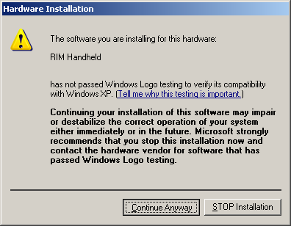
- If the Hardware Wizard appears in Step 1, you will see this screen. If you do not see this screen please proceed to the next step.
Your Blackberry driver will now be finished installing. Click Finish.
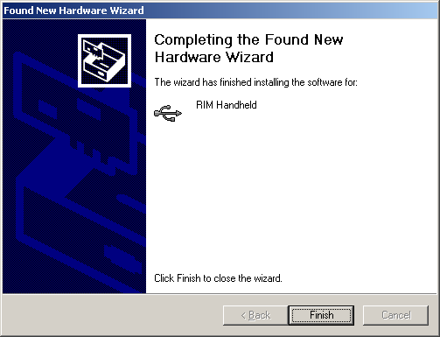

- Open the Blackberry Desktop Manager and click on the Options menu. [Note: If asked to choose your mail profile, click OK.]
- Select Hide When Minimized. Click on the Options menu and open Connection Settings.
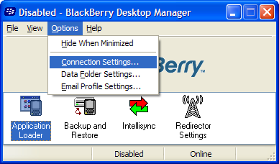

- Select the Connection drop-down menu and choose USB and click OK.
[Note: You will also see your Blackberry PIN number next to USB]
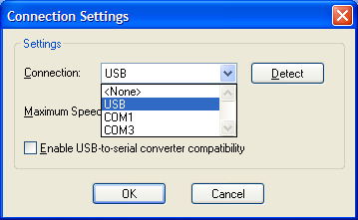

- You will be prompted to generate an encryption key. Click OK.
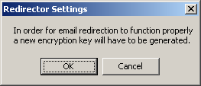
- Move your mouse around the screen in order to generate the encryption key.
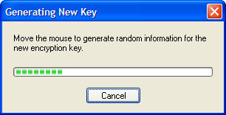
- Your Blackberry is now linked to the Juniper internal Blackberry Enterprise Server. You BlackBerry will ask you to set a new password. This password must be a minimum of five characters in length.
- Double-click on the Intellisync icon.
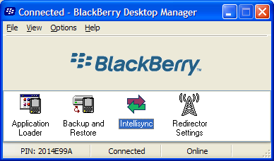

- Click Configure PIM…
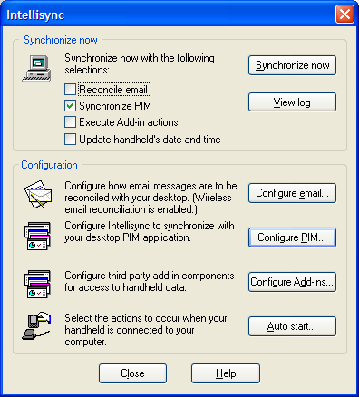

- For the PIM (Personal Information Manager) options, only one default option needs to be changed. Highlight Calendar and click the Choose button on the right.
[Note: If this already shows “BlackBerry Wireless Sync” you may skip to Step 13.]
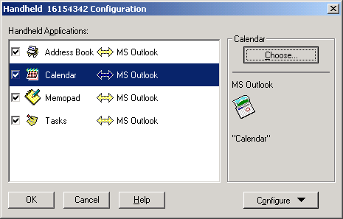

- Scroll Available Translators list to the top and select BlackBerry Wireless Sync. Click OK.
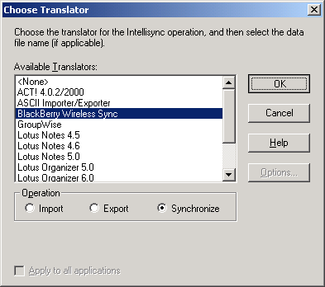

- Your PIM options should now look similar to the screenshot below. If this is true, click OK.
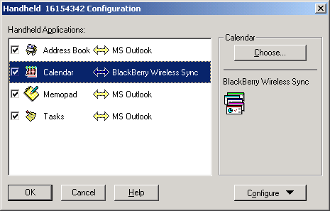

- Click Auto Start…
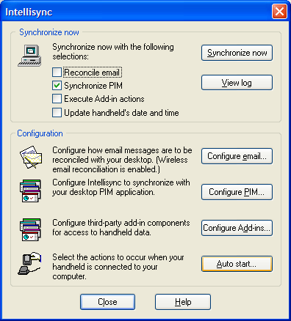
- Check the boxes for Reconcile Email and Synchronize PIM and then click OK.
Note: These are the check boxes found within the Auto start… area. They are not the check boxes at the top of the Intellisync options window shown in step 10.
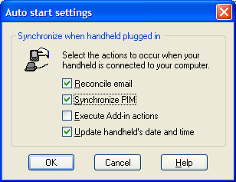
- It is now safe to close the Intellisync options window by clicking on Close.
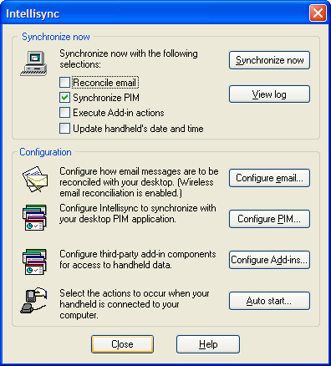

Your Blackberry software is now configured to automatically detect your Blackberry when it is plugged into the USB cable and synchronize your contacts, calendar, tasks and memos all from Microsoft Outlook. This will happen every time you connect with the USB cable.
Note: If your Blackberry handheld has a password on it, the Synchronization process does not automatically begin unless the password has been entered into the device.

